January
2022
Sunday | Monday | Tuesday | Wednesday | Thursday | Friday | Saturday
 |  |  |  |  |  | 1
2 | 3 | 4 | 5 | 6 | 7 | 8
 | Day 1 | Day 2 | Day 3 | SNOW Day | Day 4
9 | 10 | 11 | 12 | 13 | 14 | 15
 | Day 5 | Day 6 | Day 1 | Day 2 | Day 3
16 | 17 | 18 | 19 | 20 | 21 | 22
 | Martin Luther King, Jr. Day – No School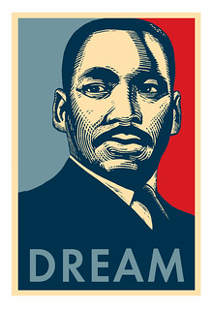 | Day 4 | Day 5 | Day 6 | Day 1
23 | 24 | 25 | 26 | 27 | 28 | 29
 | Day 2 | Day 3 | Day 4 | Day 5 | Day 6
30 | 31  Day 1
Updated 1/7/2022

